SIMPLE LINEAR REGRESSION
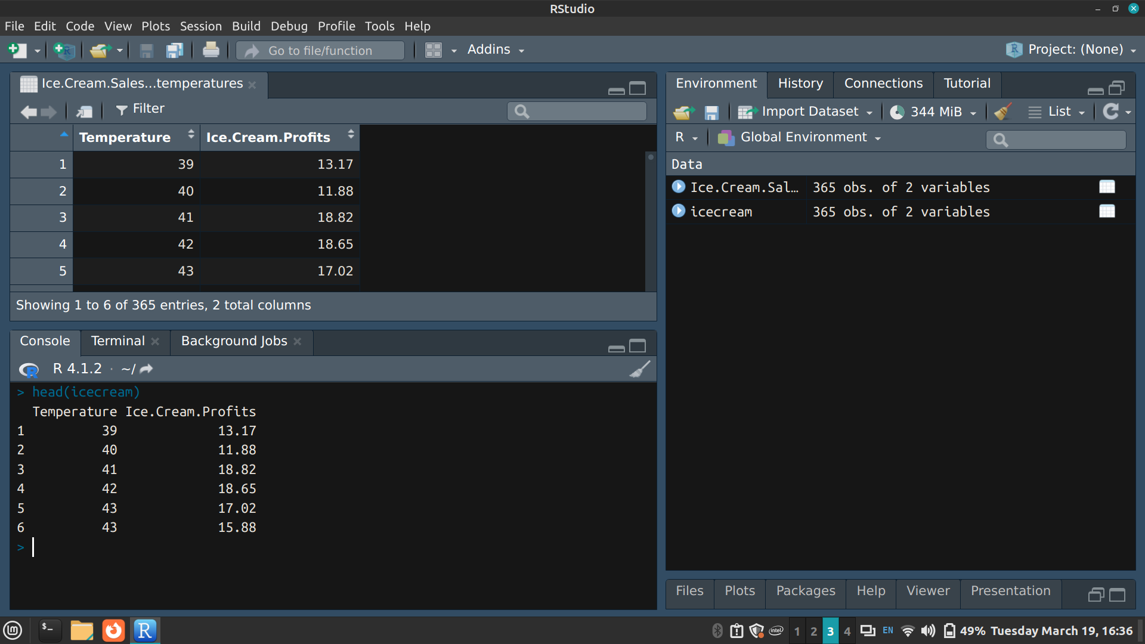
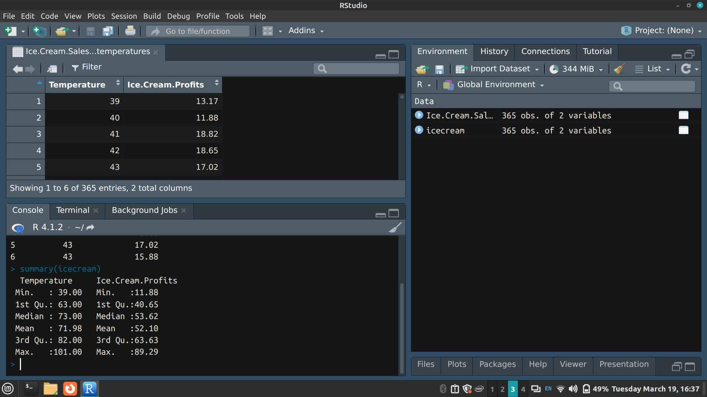

Renaming variables
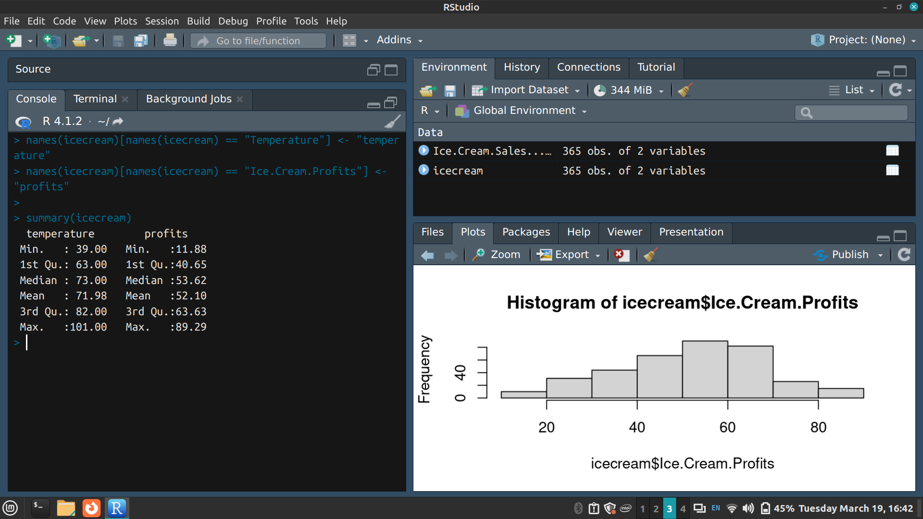

> hist(icecream$profits)
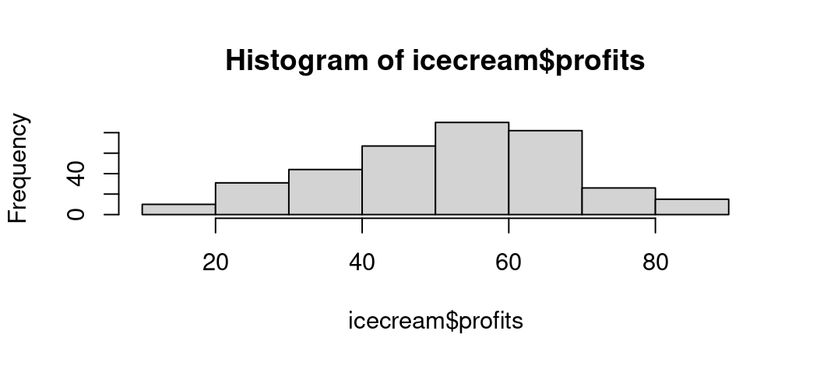
The ice cream profits roughly follow a normal distribution as it is bell-shaped

> plot(profits ~ temperature, data = icecream)
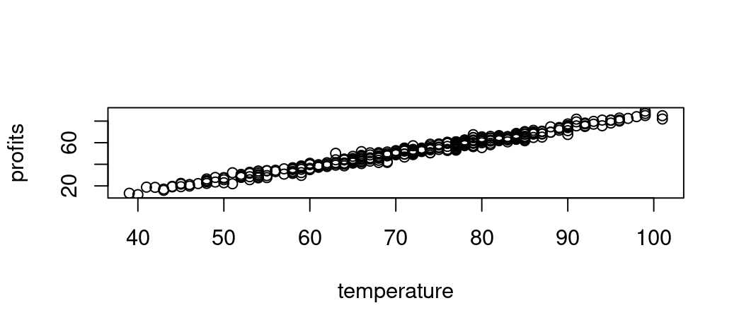
The relationship between profits and temperature looks roughly linear

> temperature.profits.lm <- lm(profits ~ temperature, data = icecream)
> summary(temperature.profits.lm)
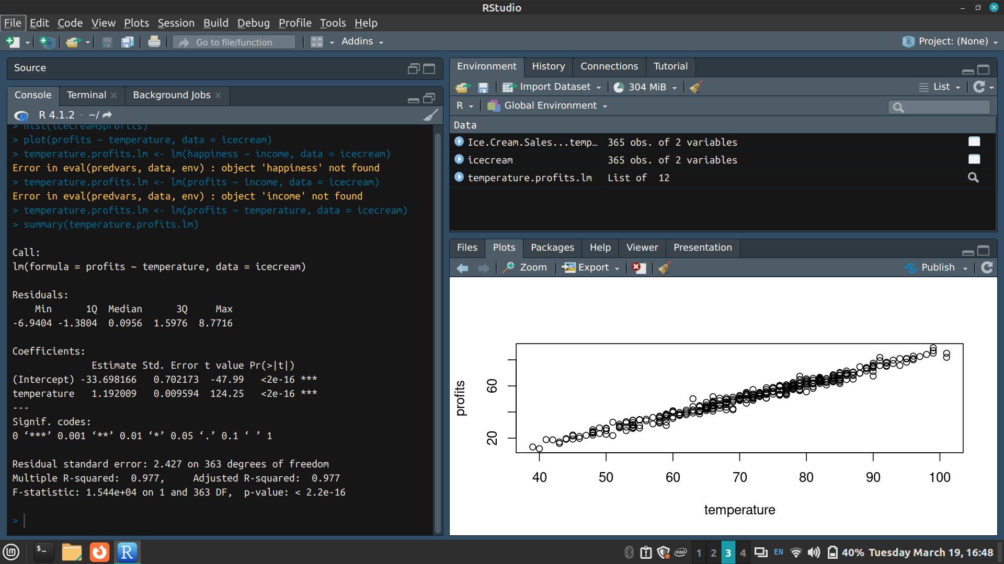
p-value: < 2.2e-16
Hence the model fits the data well
And there is a significant positive relationship between temperature and ice cream profits with a 1.192009 increase in profits for every unit increase in temperature

> plot(temperature.profits.lm)
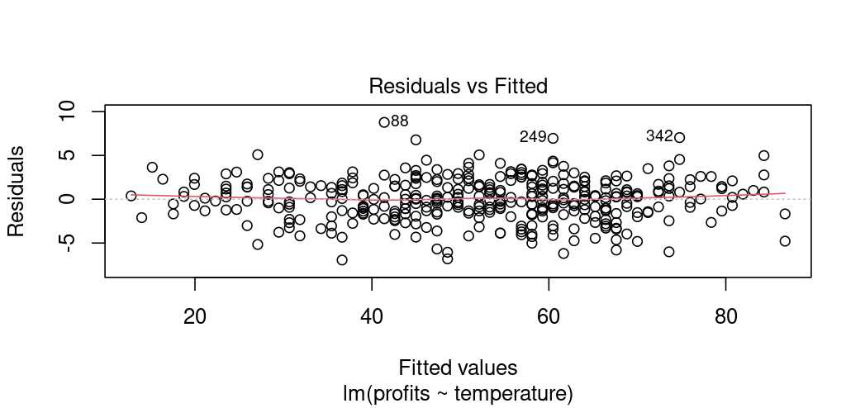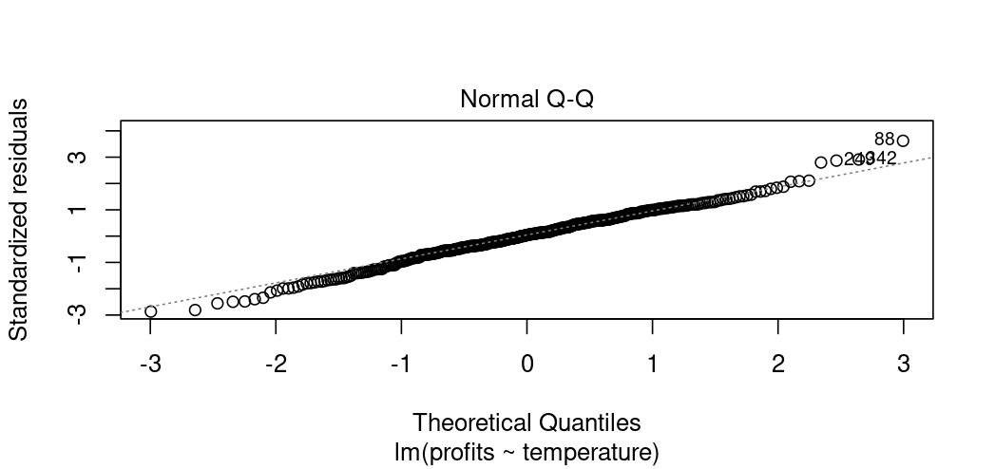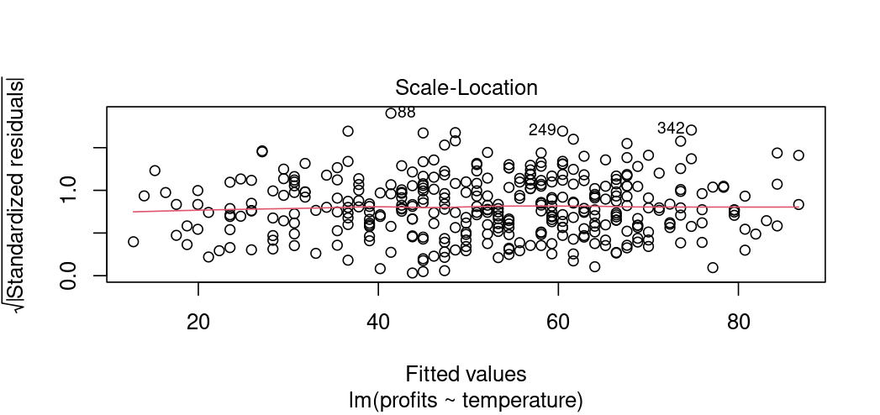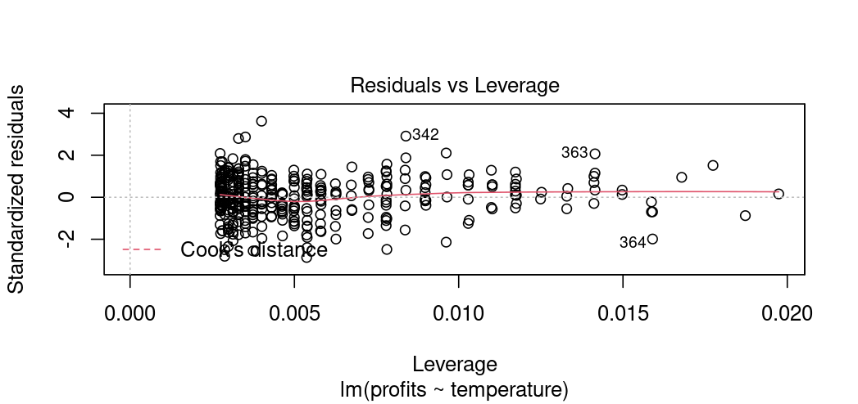
The normal Q-Q plot forms an almost perfectly one to one line with the theoretical residuals from a perfect model
Hence, our model meets the assumption of homoscedasticity

> icecream.graph <- ggplot(icecream, aes(x=temperature, y=profits)) + geom_point()
> icecream.graph
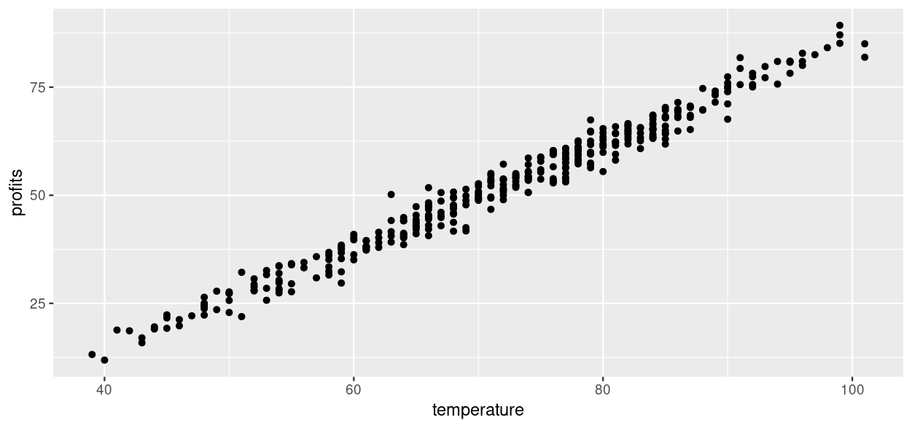

> icecream.graph <- icecream.graph + geom_smooth(method="lm", col="black")
> icecream.graph
`geom_smooth()` using formula = 'y ~ x'
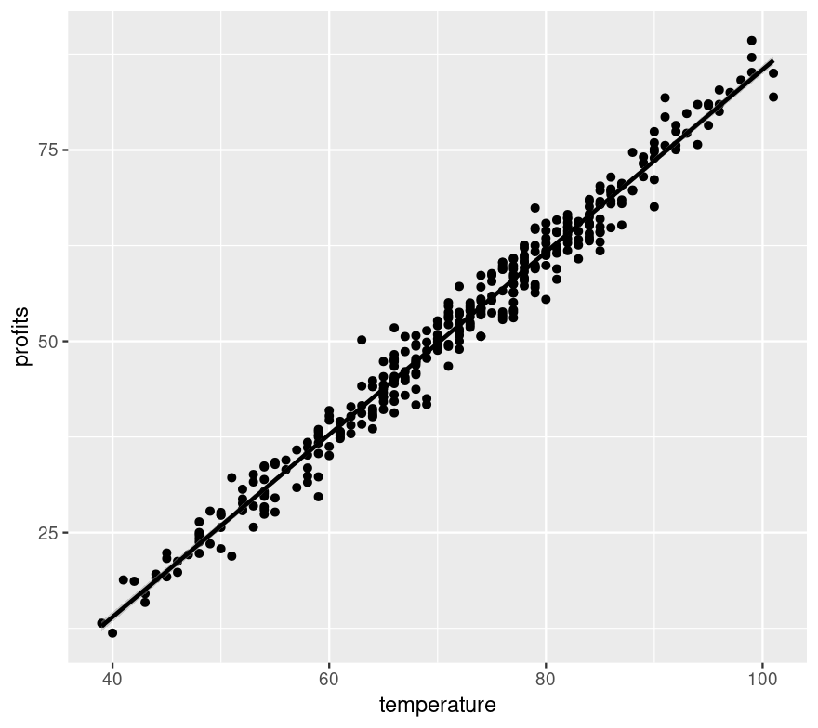

> icecream.graph<-ggplot(data = icecream, aes(x = temperature, y = profits)) +
+ stat_poly_line() +
+ stat_poly_eq(use_label(c("eq", "R2"))) +
+ geom_point()
> icecream.graph
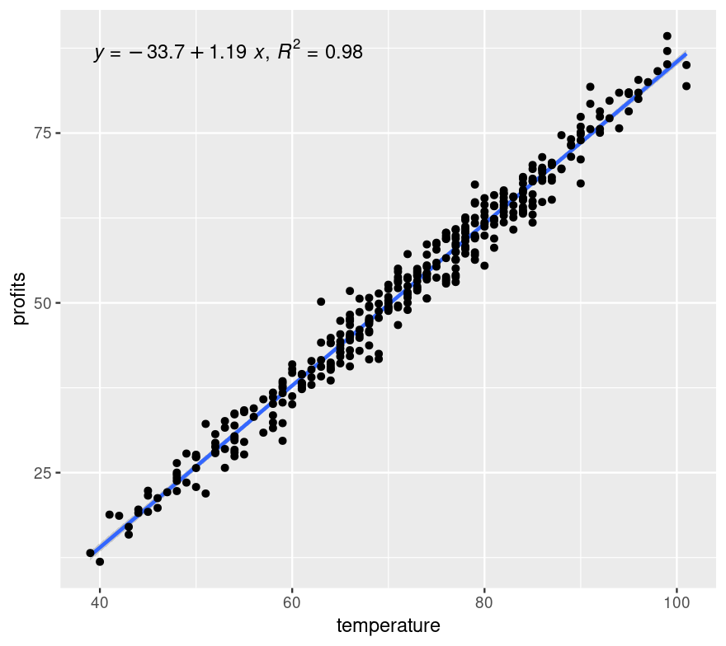

> icecream.graph <- icecream.graph + theme_light() + labs(title = "ice cream profits as a function of temperature")
> icecream.graph
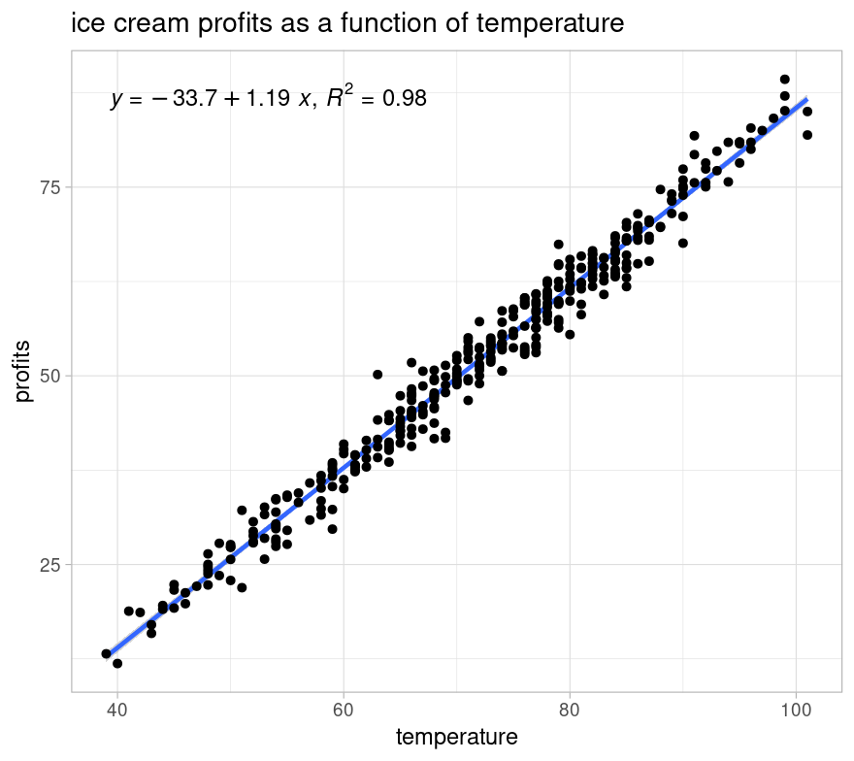

MULTIPLE LINEAR REGRESSION
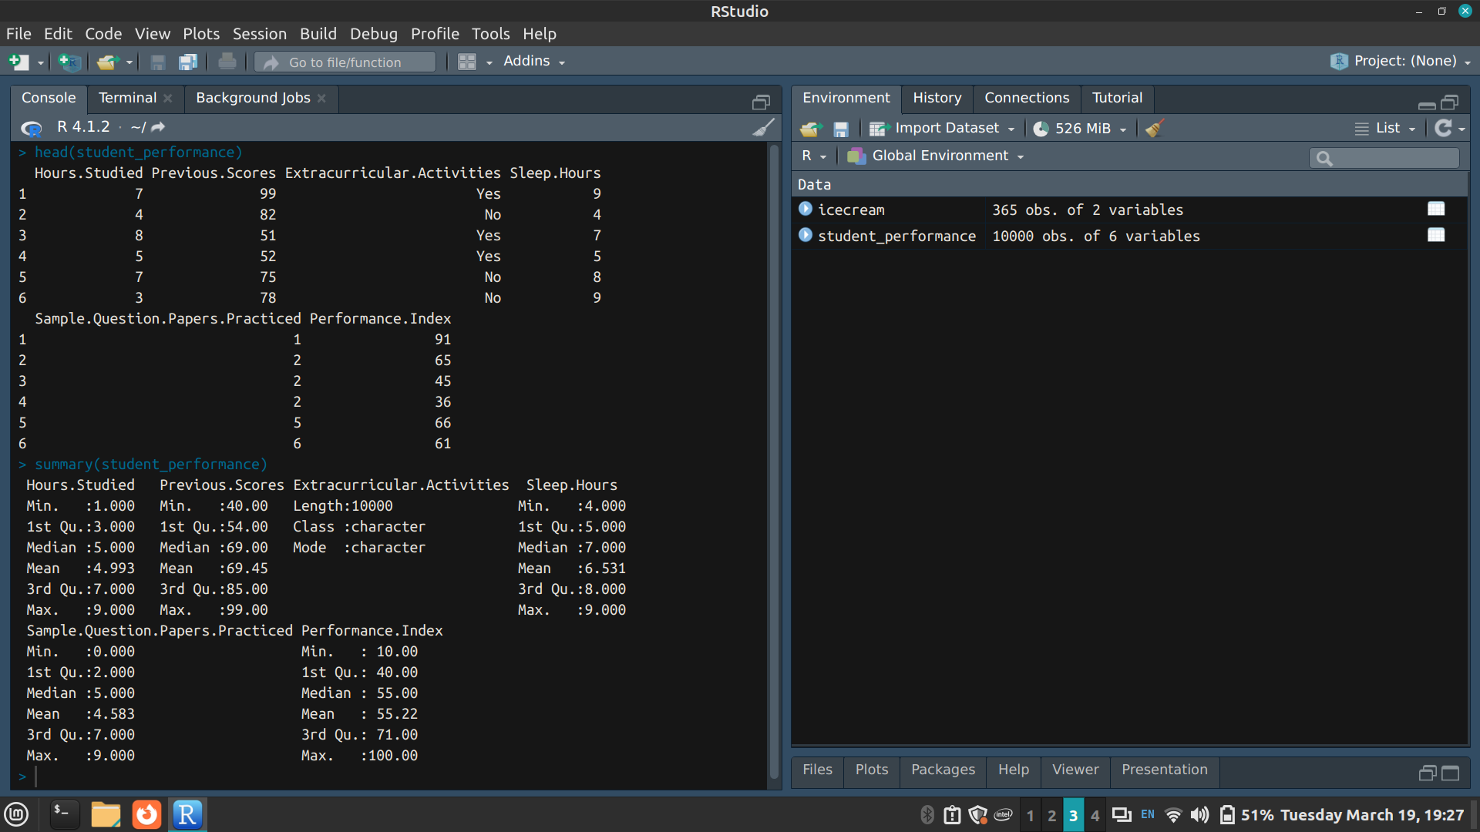

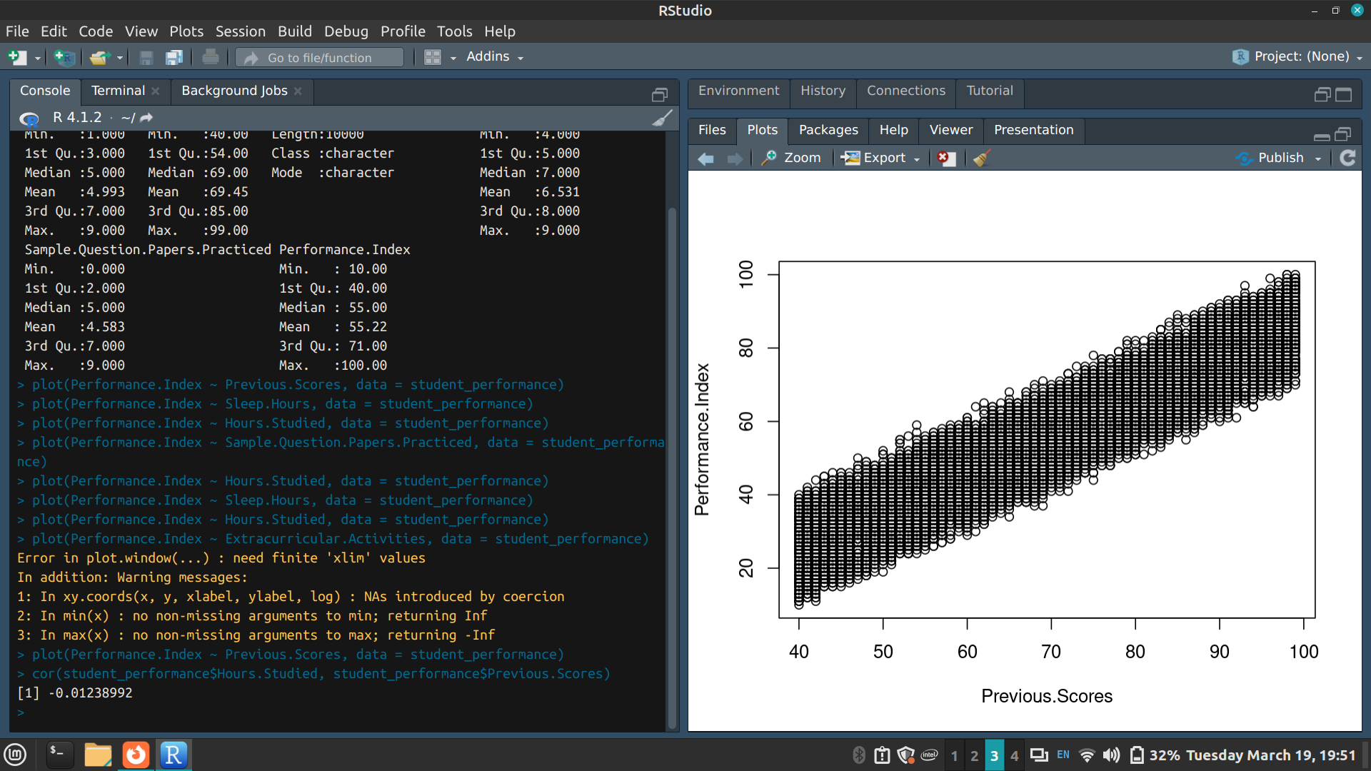
There is no autocorrelation between the 2 independent variables

> hist(student_performance$Performance.Index)
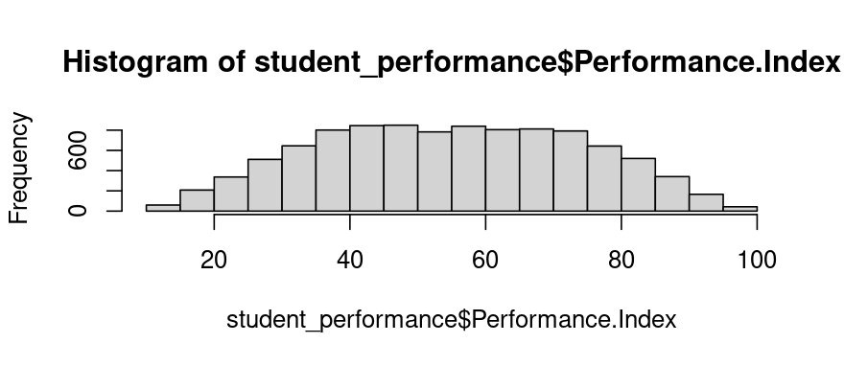
The performance index of students roughly follow a normal distribution as it is bell-shaped

> plot(Performance.Index ~ Previous.Scores, data = student_performance)
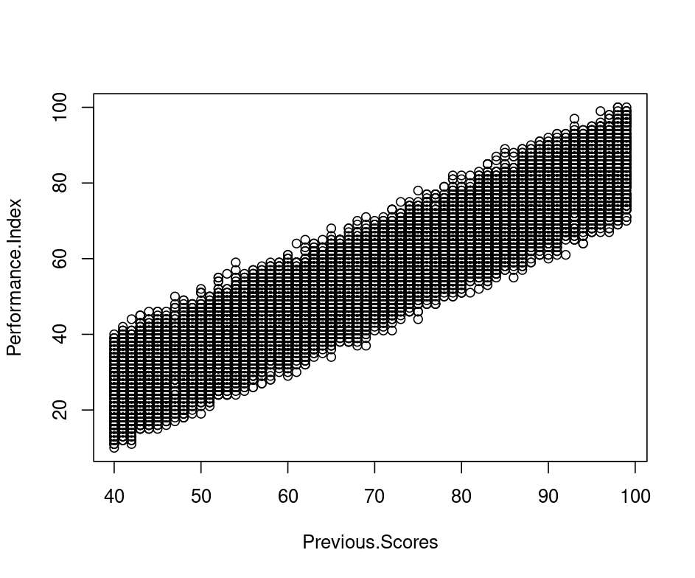

> plot(Performance.Index ~ Hours.Studied, data = student_performance)
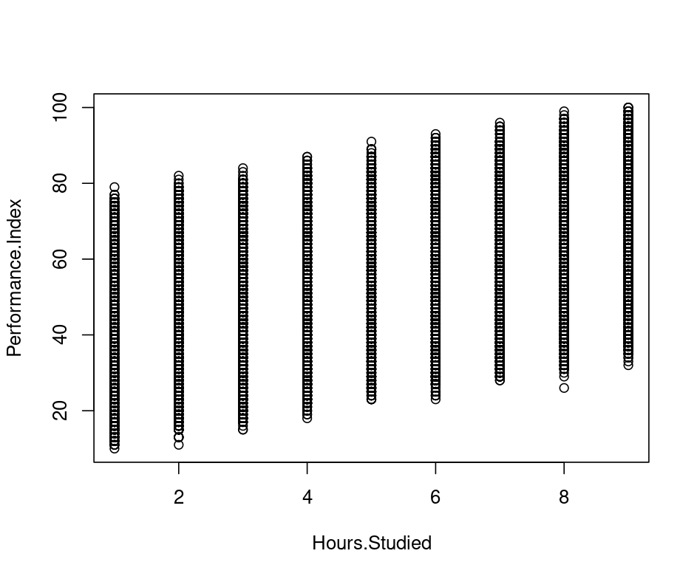

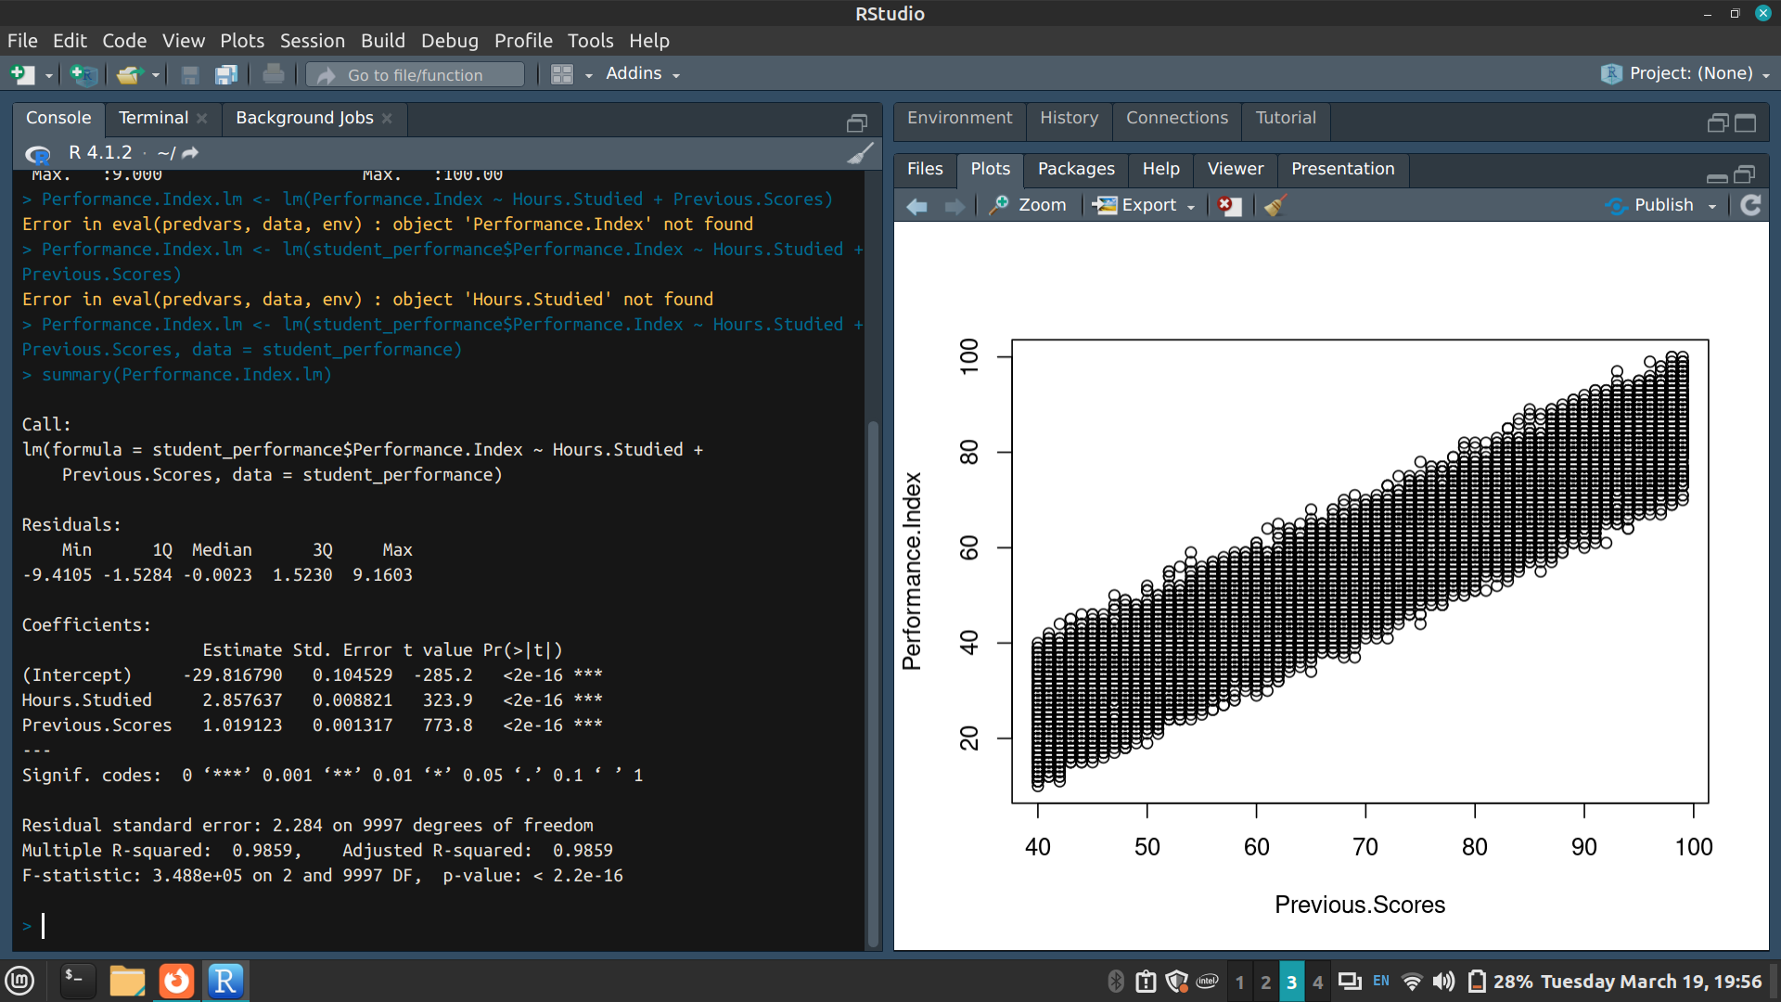
The estimated effect of previous scores on the performance index is 1.019123
And the estimated effect of the number of hours studied on the performance index is 2.857637

p-value: < 2.2e-16
Hence the model fits the data well

> plot(Performance.Index.lm)
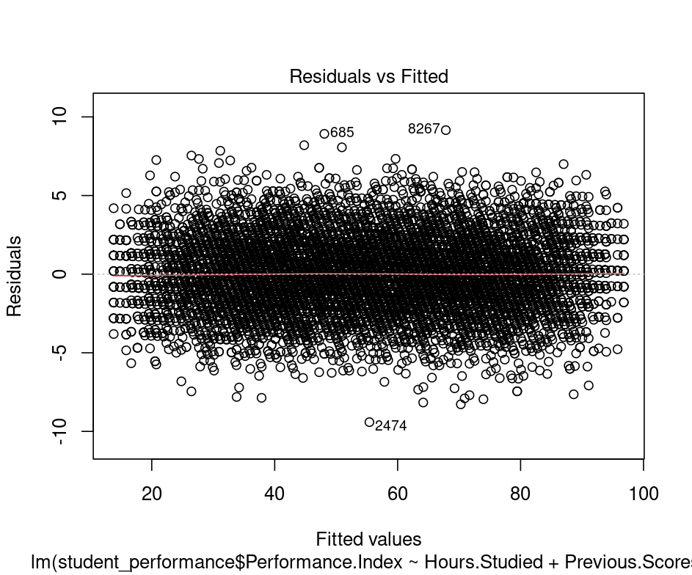
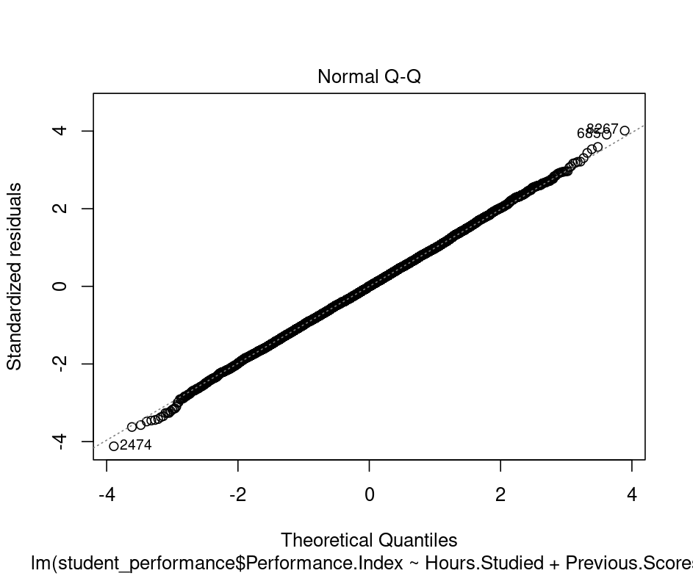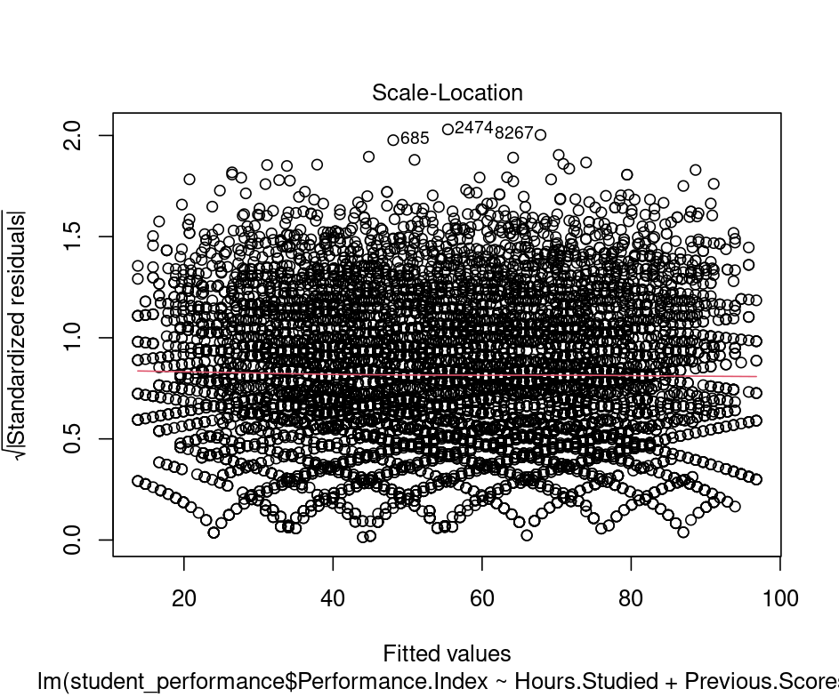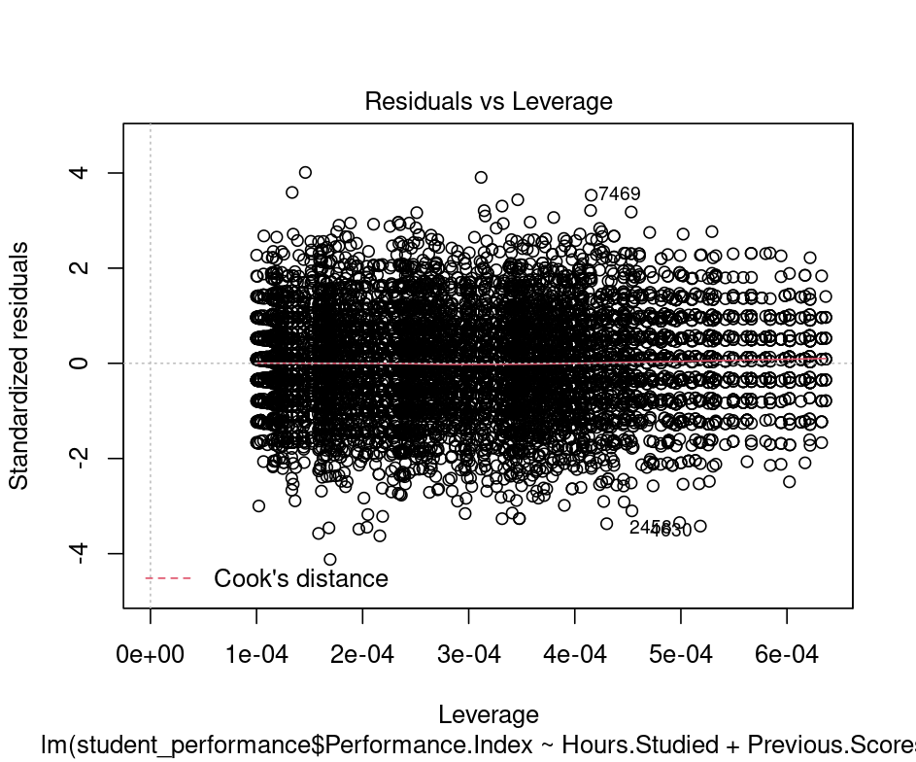
The normal Q-Q plot forms an almost perfectly one to one line with the theoretical residuals from a perfect model
Hence, our model meets the assumption of homoscedasticity

> predicted <- predict(Performance.Index.lm)
> plot(student_performance$Performance.Index ~ predicted, col="blue", pch=16, xlab="Predicted Performance.Index", ylab="Observed Performance.Index")
> abline(lm(student_performance$Performance.Index ~ predicted), col="red")
> legend("topleft", legend=c("Observed", "Predicted"), col=c("blue", "red"), pch=c(16, NA), lty=c(NA, 1))
